**15A – Length Contraction**

**Topics:** Special relativity, Lorentz transformations, length contraction, simultaneity.

**Summary:** Students first establish the relationships between the times and locations that go into the length measurement of a moving body. They then derive a formula for length contraction using the Lorentz transformations, and consider whether the two position measurements occur at the same time in both frames.

**Written by:** Michael Dubson, Charles Baily and Steven Pollock.

**Contact:** Steven.Pollock@Colorado.EDU

**Comments:** Students should be able to complete these tasks in less than 15 minutes. During our implementation, we had students work in groups on the first two questions, stopped for a quick class-wide discussion of the answers, then continued. The Lorentz transformations are written in a form that makes the symmetry between the two equations more obvious. Although some of the questions may seem trivial to instructors, we found that a number of students were confused on even the “simple” tasks, which shows that students may use the Lorentz transformations without understanding exactly what the different primed and unprimed events correspond to. Our students were told beforehand that length measurements involve a simultaneous determination of the positions of the two ends; still, some were very tentative about simply saying that the two times are equal, or even that the length is simply the difference between the two position measurements. Some students were quick to write down  from memory, without seeing how this arises from the difference in positions in the primed frame (which don’t have to be simultaneously measured, since the ruler is at rest there).



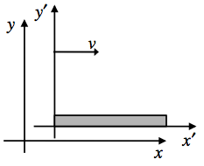



A ruler with rest length  is *at rest* in frame , which is moving to the right with speed  relative to frame . In other words, in frame  the ruler is moving to the right with speed .

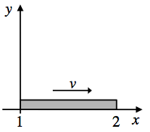In frame , the length of the ruler is measured by recording the time and position of the left and right ends of the ruler when the left end of the ruler is at :

* Event 1 = left end of ruler measured.
* Event 2 = right end of ruler measured.

In frame , how is the time of Event 1 () related to the time of Event 2 ()?

In frame , the length of the (moving) ruler is . How are the positions of Event 1 () and Event 2 () related to ?

Write out the expressions for  and  (in terms of  and ) according to the Lorentz transformations at the top of the page.





Use these to determine the relationship between  and .

Which event occurs first in frame ? Briefly explain.